Handout 1: Sounds All Around
The clips in this video show some of the interesting ways that sound behaves. For each clip, describe what you observed. Then describe one thing the clip tells you about sound or something that the clip makes you wonder about sound.
Clip Description | What did you observe? | What does the clip tell you about sound? or What do you wonder about sound?
Bell in vacuum jar
Spaceship
Horn or whistle from a moving vehicle
Tree falling
Wine glass shattering
Lightning and thunder
Mosquito tone
Orchestra tuning up
Echo
Handout 2: Unit Overview

Voices, music, and other sounds can enhance your media and digital design projects by evoking emotion, establishing a setting, helping to develop characters, and moving the plot along.
Whether you are recording sound for a radio, television, or film production, working in a music recording studio, or setting up the sound system for a live concert or a campaign speech, understanding the science of sound will help you do your job better and get better results. Imagine . . .
. . . an interview that captures the nuances of the speaker’s voice
. . . a recorded song where every voice and instrument meld together seamlessly
. . . sound effects for a movie that make you feel like you are in the middle of the action
. . . a live concert in which everyone can hear the performers’ music as it was meant to be heard
A good understanding of the science of sound—which is also known as acoustics—can help you choose and set up audio equipment for any recording task. You’ll know what causes feedback, and how you can set up equipment to avoid it; what happens when speakers are out of phase, and how you might you fix them; and what microphones are best for recording interviews versus recording music.
In this unit, you will learn about sound by conducting hands-on investigations, using sound editing software, and exploring computer simulations of waves.
Your work in this unit will revolve around the following questions:
- How are sound waves produced, and how do they travel?
- How can I make use of my knowledge about sound waves when creating the audio component of my media and digital design projects?
Unit Project
You will create a sound effect by using sound editing software to manipulate sound waves, and then write an explanation of what you did in terms of wave properties, such as frequency and amplitude. You will collaborate with classmates in the production of a mini-encyclopedia, the Acoustipedia; each student will write an illustrated article explaining a topic in audio production in terms of the properties and behavior of waves (such as reflection, diffraction, and interference) and will revise the article based on feedback from other students.
What You Will Do in This Unit
Explore mechanical waves. Create waves in water and with a Slinky and observe how these waves behave.
Look at and create sound waves. Use sound editing software to “see” sound waves on the computer screen, and observe the characteristics that make one sound different from another. Create or manipulate sound waves to produce a sound effect.
Share what you have learned. Write an article for the class Acoustipedia about the science behind a topic in the field of audio production.
Vocabulary Used in This Unit
Acoustics: The branch of physics dealing with sound. (Also, the characteristics of a physical space that determine the fidelity and audibility of sound transmitted there.)
Frequency: The number of wavelengths that pass a given location during a unit of time. Usually measured in cycles/second (also called Hertz).
Wave: A disturbance that carries energy, but not matter, from one place to another. The disturbance may be mechanical or electromagnetic. Mechanical waves, such as ocean waves, sound waves, and seismic waves (earthquakes), must travel through a medium, such as water, air, or earth, and gradually lose energy to that medium as they travel.
Wavelength: The length of one complete cycle of a wave; the distance from a point on one wave to the same point on the next wave. Often represented using the Greek letter lambda (λ).

Handout 3: Anatomy of a Speaker

A microphone takes sound and converts it into an electrical signal that can be stored for later playback. A speaker takes this electrical signal and converts it back into sound. Learn more about how this works and exactly what sound is by “dissecting” a speaker.
Background Information
Speaker is short for loudspeaker. A loudspeaker consists of some kind of cabinet or enclosure with one or more drivers inside, along with any electronics needed to process the incoming electrical signal. A driver is the part of the speaker that converts the electrical signal into physical vibrations.

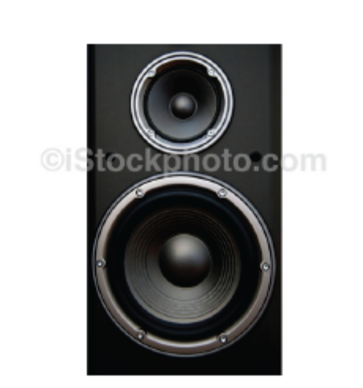
Loudspeaker with cover removed to show two drivers inside.

Speakers work because they receive electrical signals from a computer, television, or other sound system component. In this activity, since the speakers being dissected are no longer connected to one of these systems, you will use a battery to provide the electrical signal. While a sound system sends a signal consisting of a varying electrical voltage, the battery can only send a very simple signal—it’s either on or off!—so there won’t be much variety in the sounds produced during this investigation.

Materials
- Safety goggles
- Small screwdrivers in a variety of sizes
- Scissors
- Craft knife or utility knife
- Wire cutters/strippers
- 2 alligator clip cables
- 9-volt battery
- Voltmeter, ammeter, or multimeter

Procedure
Note: Try to do as little damage as possible to the speaker at each stage, so that it continues to function throughout as much of the procedure as possible.

1. Put on your safety goggles.
You may need to pry the speaker apart using a screwdriver, and pieces of the speaker may go flying through the air. Even if your team is not prying apart the speaker, other teams may be, and the flying pieces can travel several feet.

2. Remove the driver.
What needs to be done to expose the driver varies widely from speaker to speaker. Here are some general guidelines:
- Most speakers have some kind of mesh or grill cover on the front. Try to remove this.
  - If this cover is screwed on, remove the screws and lift the cover off.
  - If there are no visible screws, you may be able to pry the cover off with a screwdriver.
  - A mesh cover can be cut away with scissors or a knife.
- Once the cover has been removed, you will see the front of the driver.
  - If the driver is held in place with screws, unscrew them and carefully remove the driver.
  - If there are no visible screws, see if you can simply lift the driver out.
  - If you are not able to remove the driver from the front of the speaker, you will need to take apart the speaker cabinet. Look for small screws on the front and back. If there are no screws, or if removing the screws does not enable you to open the cabinet, you may need to pry the cabinet apart with a screwdriver. Once the cabinet is open, remove the driver.

If you are unable to remove the driver, you should still try to complete as much as possible of the remaining steps.
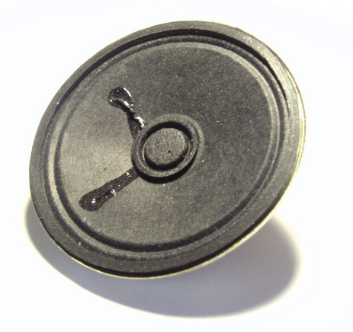
A loudspeaker driver that has been removed from its cabinet.
Image by Richard Wheeler (Zephyris), licensed under Creative Commons Attribution ShareAlike 3.0

3. Disconnect the driver wiring from the rest of the speaker and connect it to the battery.
Two wires connect the underside of the speaker cone to the inside of the speaker cabinet. (Any other wires can be cut and then ignored.)
- The wires leading from the cone may be connected to the rest of the speaker by small plugs. If this is the case, unplug the wires, and attach an alligator clip cable to each plug remaining on the driver.
- If the wires leading from the cone cannot be unplugged, use wire cutters/strippers to cut the wires. Then strip some insulation off the ends of the wires and attach an alligator clip cable to the end of each wire. Attach the free end of one alligator clip to one battery terminal.

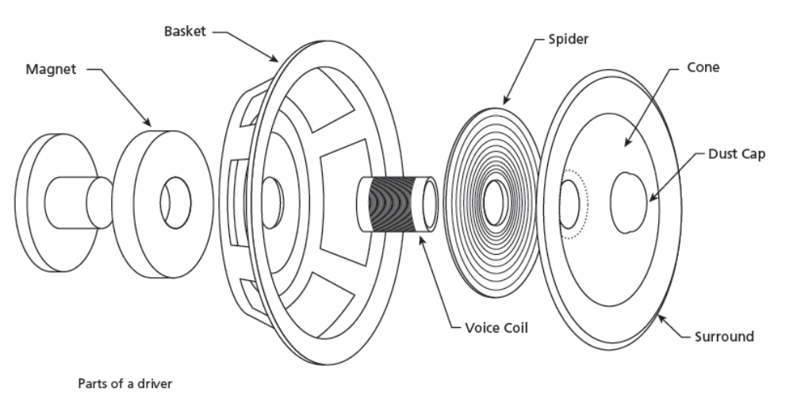
Touch the free end of the other alligator clip to the other battery terminal to complete the circuit. Try this repeatedly and answer the following questions:
- What do you hear?
- What does the cone do?
- What do you see and hear if you connect the wires to the opposite terminals of the battery?

Leave the alligator cables attached to the driver, and leave one alligator clip attached to the battery.

4. Expose the spider and voice coil.
Use a craft knife or utility knife to remove part of the cone by cutting halfway around the surround and then across the cone and dust cap. (Remove the half of the cone that does not have wires attached to it.) Again, use the free end of the alligator clip cable to complete the circuit with the battery.
- What do you hear?
- What parts of the driver move?
- What changes if you connect the alligator clip cables to the opposite terminals of the battery?

Use the knife to remove half the spider. Again, connect the free end of the alligator clip cable to the battery. Look for the voice coil (a coil of very fine copper wire).
- When you complete the circuit with the battery, what does the voice coil do?

5. See what you can determine about how a speaker works.
- Based on your observations, what have you figured out about how a speaker works?
- What questions about how a speaker works do you still have?

6. Connect the speaker wires to a voltmeter or ammeter.
Movement of the needle on a voltmeter or ammeter indicates that electricity is flowing.
- Move the cone in and out with your fingers. How does the meter respond?
- Can you make the cone move by blowing on it or shouting near it?
- Given your observations, what ideas do you have about how microphones work?
Handout 4: From There to Ear

Any source of sound, such as a tuning fork, a loudspeaker, or a musical instrument, vibrates. This causes vibrations in whatever separates the vibrating object from our ears—usually air, but vibrations can pass through solids and liquids as well. If the vibrations are strong enough to travel to our ears, and if the rate of vibration is within the range our ears are sensitive to, our ears turn that vibration into a signal that our brains perceive as sound.
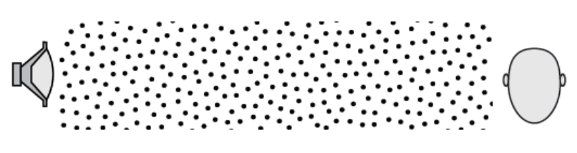

In the absence of sound, the air molecules between the speaker and the ear are spread out evenly.
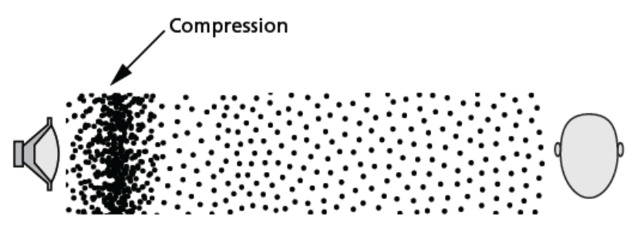

In response to an electrical signal, the speaker cone moves to the right, hitting the nearby air molecules and resulting in a region of compressed air.

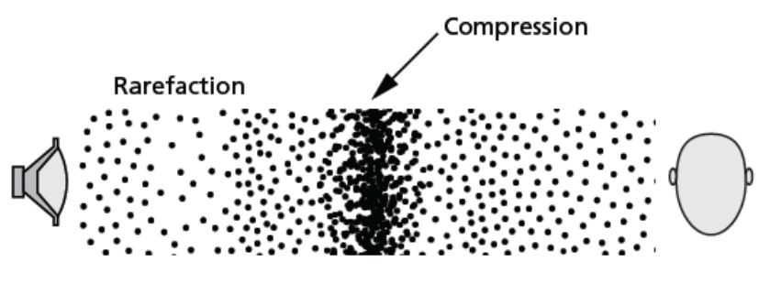

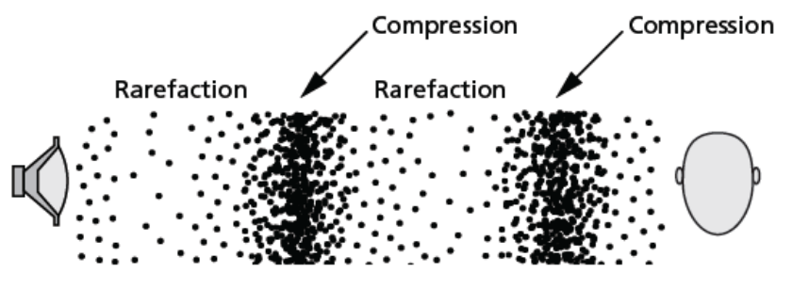
The air molecules bump into other molecules, and so on, resulting in a region of compression that moves away from the speaker. Meanwhile, as the speaker cone moves to the left, a region of lower air pressure, called a rarefaction, forms.

The speaker cone continues to move in and out, creating alternating regions of compression and rarefaction that travel to a listener’s ear.
Handout 5: Playing the Eardrum
When you listen to sound from a speaker, vibrations travel this path to your ear:
diaphragm of the speaker
↓
air molecules between you and the speaker
↓
air molecules in your auditory canal
↓
eardrum (tympanic membrane)
↓
tiny bones in the middle ear
↓
fluid in the cochlea
↓
tiny hairs in the fluid
The motion of these hairs results in an electrical signal being sent along the auditory nerve to your brain.

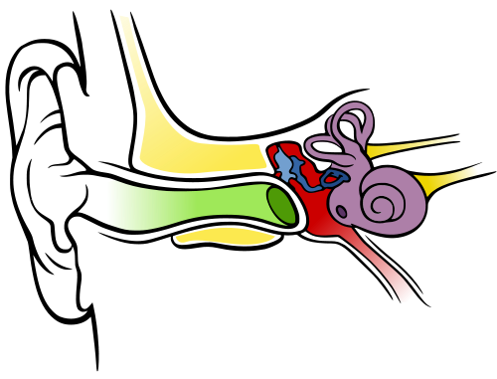
Ear drum
Cochlea
Auditory nerve
Auditory canal
Bones of the middle ear
Loud sounds can damage the tiny hairs in the cochlea, resulting in permanent hearing loss. The volume at which damage occurs is much lower than the volume at which a listener feels pain.

Credit: Chittka L, Brockmann; Creative Commons
Attribution Generic 2.5
Handout 6: Where Does Sound Go?

Where will the sound waves go? Will they reach listeners at locations A, B, C, and D? Draw your prediction.
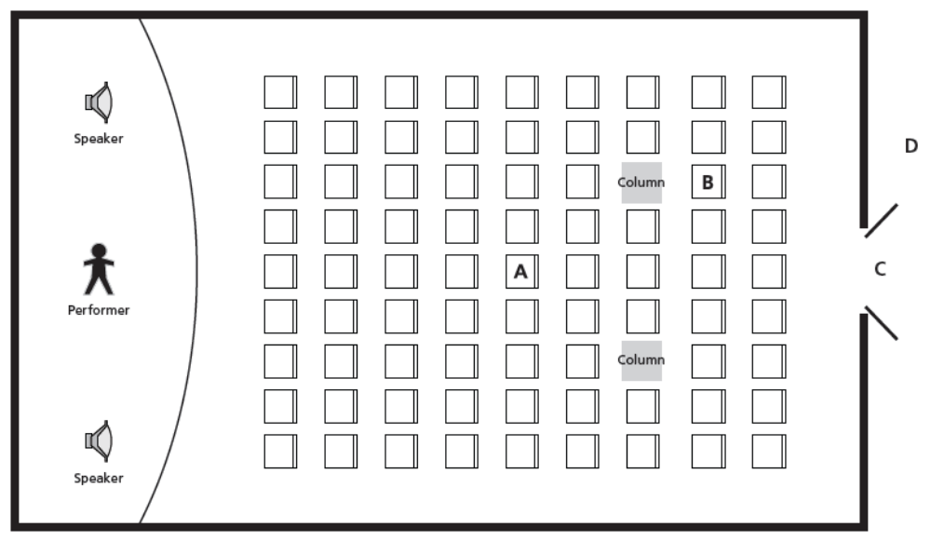

After you have investigated the behavior of water waves, draw your revised prediction of how the sound waves in this room will behave.
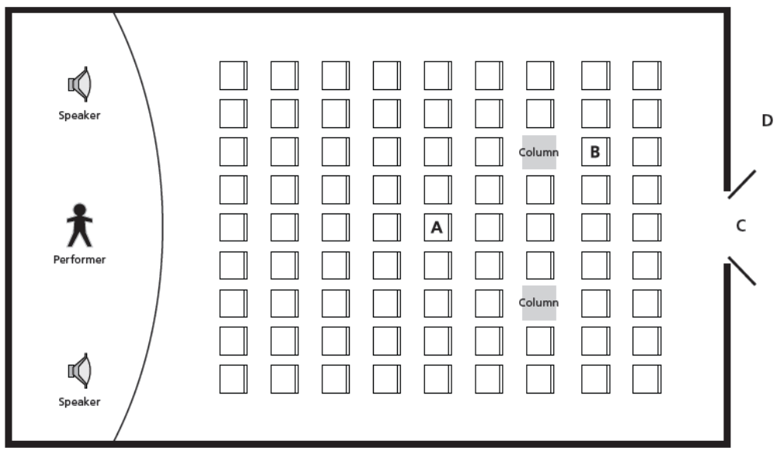
Handout 7: Water Waves Exploration

In this investigation, you will create waves in water and observe how these waves interact with each other and with their environment. You will then use what you have learned to predict how sound waves will behave in an enclosed space.

Materials
- Ripple tanks (such as an 8 x 8 clear Pyrex® baking dish)
- Pencil with an eraser
- Blocks of various sizes, small enough to fit in the ripple tank

1. Circular Pulses
- Make a ripple in the water by poking the surface with the eraser end of a pencil. This singular disturbance is called a pulse. Describe (in words) and draw what you observe. Add arrows to your drawing showing the direction of movement. How does what you see change over time?

- Create another pulse with the eraser. What happens when the ripple reaches the sides of the tank? Describe and draw what you observe. Does the ripple reach all sides of the tank at the same time? Why or why not?

- Make two pulses by poking the surface of the water in two different locations at the same time. Describe and draw what you observe. How do the height and depth of the ripples change when two ripples meet each other? Draw another picture showing what the waves would look like from the side (imagining that you can see through the side of the tank).

2. Circular Periodic Wave
Periodic waves can be created by repeatedly poking the surface of the water in the same location at a constant pace.

- Make two circular periodic waves by repeatedly poking the surface of the water in two different locations at the same time. Describe and draw what you observe.

- Place one of the blocks in the ripple tank. (You will probably need to hold it down to keep it from floating away.) Create a periodic wave. What happens when the wave reaches the block? Draw what you see.

- Position two of the blocks so that there is a small gap between them. Create another periodic wave. What happens when the wave reaches the gap? Change the size of the gap and see how that affects the behavior of the wave. Describe and draw what you see.

3. Refining Your Prediction
In addition to the specific steps listed in this handout, try any other setups needed to help test your predictions on Handout 6.
Handout 8: Properties of Waves

Label the following parts and properties of the wave: wavelength, amplitude, crest, and trough.
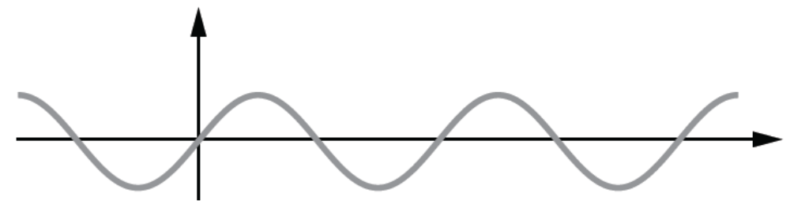

Use the space below to take notes or make sketches of the following parts, properties, and behaviors of waves.
Parts/properties of a wave:
- crest
- trough
- amplitude
- wavelength
Wave behaviors:
- reflection
- diffraction
- interference

Handout 9: Measuring the Speed of Sound
In this activity, you will measure how fast sound travels in air.
Note: This procedure cannot be carried out indoors, because the sound will reflect off too many surfaces.
Materials
- Two wooden blocks
- Tape measure
- Stopwatch
Procedure
- Give one team member the wooden blocks (the “Clapper”), one the tape measure (the “Measurer”), and one the stopwatch (the “Timer”). Have the Clapper stand about 10 meters away from a large vertical wall.
- Have the Clapper clap the blocks together quickly and loudly. If you don’t hear an echo, have the Clapper take a large step away from the wall, and clap the blocks again. The Clapper should continue to step away from the wall and clap the blocks until you all hear an echo that is easily distinguished from the original sound.
- Have the Timer stand next to the Clapper, at the same distance from the wall. Have the Clapper clap the blocks again. The Timer should then measure the time from the original sound until the echo.
- Have the Measurer measure the distance from the blocks to the wall.
- Repeat steps 3 and 4 a few times. You can have the Clapper stand in the same spot, or you can take a measurement from farther away if the echo can be clearly heard.
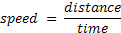
- As a team, calculate the speed of sound using the following formula:
Data
Trial | Time | Distance from Wall | Total Distance Traveled by Sound | Speed of Sound
1
2
3
Average
Analysis
Based on the value you calculated for the speed of sound, is the following a good rule?
If you can count to 5 from the time you see the lightning to the time you hear the thunder, the lightning strike was a mile away. [One mile equals 1,609.3 meters.]
If so, why? If not, what rule would you suggest, and why?

Handout 10: Waves on a Slinky©
How can you learn more about sound waves when you can’t see them? One way is to study similar phenomena that you can see. In this investigation, you will create and observe waves in a Slinky®, and record your observations in words and sketches.
Materials
- Original Slinky
- Optional: Monofilament (such as fishing line)
- Other Slinky, such as Slinky Jr. or plastic Slinky
- Masking tape
Background Information
In this investigation, you will create two types of waves in the Slinky, called transverse waves and longitudinal waves.

Transverse Waves
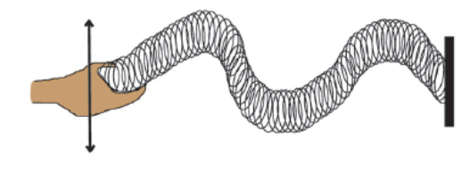
To create a transverse wave, give one end of the Slinky a quick jerk to the left or right, and then return the end to its starting point.

Longitudinal Waves
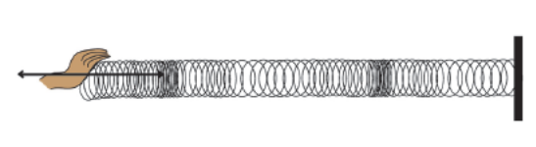
To create a longitudinal wave, hold the end of the Slinky with one hand, grab several coils with your other hand, pull them toward you, and then release them.

To observe some of the wave properties, you may need to change the amount of tension in the Slinky—the more you stretch it, the greater the tension. However, be careful not to stretch the Slinky so far that it will not return to its original shape.
Procedure
For most of the steps in this procedure, you will create both transverse and longitudinal waves. Be sure to draw and describe your observations for both types of waves.

1. Set up the Slinky.
Option A: Lay the Slinky on the floor and stretch it out to a length of several feet. Have two team members hold the Slinky in this position, one at each end. A third team member should stand where he or she has a good view of the whole Slinky.

Option B (for longitudinal waves only): Thread a piece of monofilament through the center of the Slinky, and tie each end of the monofilament to a fixed object so that the middle of the Slinky does not sag. (There is less friction between the Slinky and the monofilament than there is between the Slinky and the floor, which makes it easier to observe some wave properties.) Stretch the Slinky out to a length of several feet. Have two team members hold the Slinky in this position, one at each end. A third team member should stand where he or she has a good view of the whole Slinky.

2. Make pulses.
- Hold one end of the Slinky fixed and use a single jerk or pull to send a disturbance along the Slinky. This non-repeating disturbance is called a pulse. Draw and describe what you see for both the transverse pulse and the longitudinal pulse.

- Send another pulse down the Slinky, making sure that the pulse has enough energy to reach the other end. For both the transverse and the longitudinal pulses, describe what happens when the pulse reaches the end of the Slinky.

- Send two pulses down the Slinky at the same time, one from each end. Draw and describe what happens for both the transverse and longitudinal pulses.

- What affects the speed at which the pulse travels along the Slinky? Here are some factors to test:
- The size of the pulse
- The surface on which the Slinky rests (bare floor, carpet, monofilament)
- The size or material of the Slinky (Compare an original Slinky to a Slinky Jr. or plastic Slinky)
- The tension in the Slinky (determined by how much the Slinky is stretched)

  - How much and in what direction does a single coil of the Slinky move as the pulse travels? (To make this easier to see, mark one coil and the table or floor directly beneath that coil with small pieces of masking tape.)
- How does the movement vary based on the size of the jerk or pull you use to get the pulse started?

3. Make periodic waves.
Using repeated motions to send pulses along the Slinky at regular intervals produces a periodic wave.

- Generate a periodic wave by jerking or pulling the Slinky at a frequency of once per second. Draw and describe what you see for both transverse and longitudinal waves.

- Try to produce the following patterns in the Slinky:
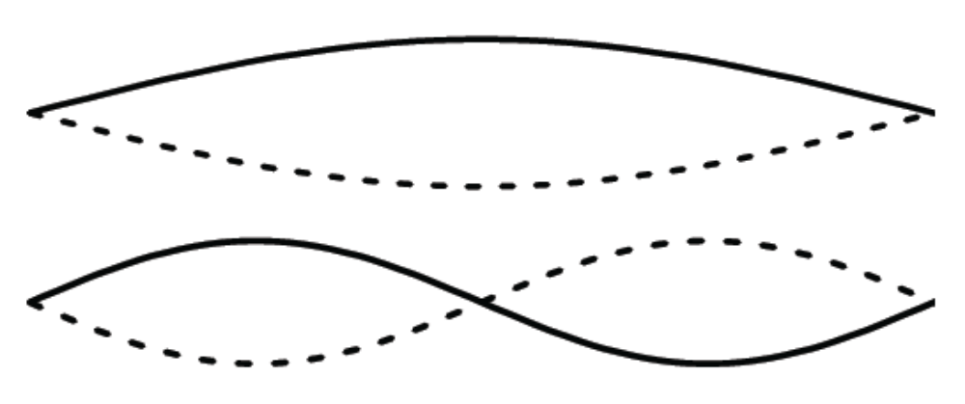

Notice that in the first pattern, the Slinky is almost motionless at two points; in the second pattern, the Slinky is almost motionless at three points. Can you create a pattern in which the Slinky is motionless at four points? Draw this pattern.

Handout 11: Wavelength, Frequency, and Speed

Wavelength and frequency are related to each other and to wave speed according to this equation:
v = f λ
where v is the speed of the wave, f is the frequency, and λ (lambda) is the wavelength.

To see where this equation comes from, think of a wave as a train with many cars.
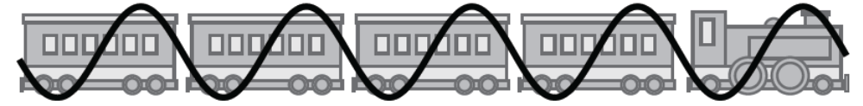
Imagine that you are watching this train go by, and you want to know its speed. One way to find out is to measure the distance between two points on the track and then time how long it takes for any one part of the train to get from the first point to the second point. You can then calculate the velocity using this equation:

That’s the same equation you used in Activity 2B to calculate the speed of sound.
But there’s also another way to calculate the speed of that train. If you know the length of the train cars, you can count how many cars pass by in a given unit of time. The train speed can then be calculated like this:

speed = number of train cars passing by per second × length of a train car

The speed of a wave can be calculated in the same way:

speed = number of waves passing by per second × length of a wave

Since the number of waves passing by per second is the frequency, f, and the length of a wave is the wavelength, λ, this gives us the wave equation:
v = f λ
In general, the frequency of a wave is set by the vibrating object, such as the speaker cone that sets a sound wave in motion or the hand that shakes the Slinky. The speed of the wave is determined by the medium, such as air or water, that the wave is traveling through. This means that the wavelength depends on both frequency and speed.
Handout 12: Seeing Sound Waves
How do scientific properties of waves, such as frequency and amplitude, relate to the properties of sound that you can hear, such as pitch, volume, and the difference between two instruments or voices? In this activity, you will answer this question by using sound editing software to “look” at the sound waves that make up speech, music, and sound effects.
Background

Sound editing programs show sound waves as a graph of sound pressure level (SPL).
The SPL is the change in the local air pressure due to the transmission of a sound wave. Regions of the wave where the molecules are close together, which are high pressure, are peaks on an SPL graph. Rarefactions, which are regions of low pressure, are troughs on the an SPL graph.
Notice that when sound waves are represented this way, the graph looks like a transverse wave.
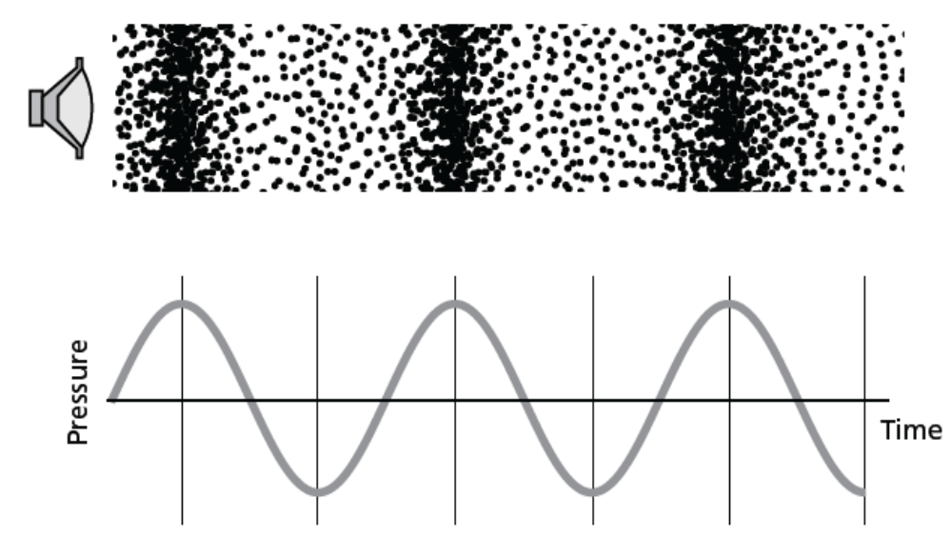
Materials
- Computer with sound editing software and sample sound files
- Optional: Microphone (can be shared among several teams of students)
- Tuning fork(s) (can be shared among several teams of students)
- Optional: Musical instrument(s)
Procedure
After completing step 1, you can do the other steps in any order. (It may be necessary for teams to work on different steps at the same time, if there aren’t enough tuning forks and microphones available for each team to have its own.)
- The basics
Open one of the sample sound files and familiarize yourself with the sound editing software by trying the following:
- Play the sound.
- Modify your view of the sound:
  - Zoom in closer to see more detail.
  - Stretch or shrink the vertical axis.
  - Use the scroll bars at the bottom and side to look at different parts of the file.
After making each change to your view of the sound, play the sound again to confirm that you are not changing the sound itself, just the way it looks on the screen.
- Connect a microphone to the computer. Record a musical tone and play it back. You can use a musical instrument, a tuning fork, or your voice to produce the note.
- Create a track using the sound editing program’s built-in tone generator.
- Turn different tracks on and off.
- View the plot of the frequency spectrum.
- Comparing different instruments
- Open one of the sample sound files from a musical instrument (e.g., Oboe_Middle_C.wav or Violin_Middle_A.wave).
- If you have a microphone and a musical instrument available, record the instrument playing the same pitch as the sample sound file. Otherwise, open another sample sound file of a different instrument playing the same note.
- Use the tone generator to create another sample at the same pitch.
- Zoom in on the graphs until you can see the wave crests and troughs. What similarities do you see among the graphs? What’s different?
- Plot the frequency spectrum for each sound. What similarities and differences do you observe?
- For each sound, at what frequency do you see the highest peak? What other peaks do you see? Record your observations in the table below. If time permits, look at recordings of other instruments as well.

Pitch (look at the same pitch for each instrument) | Musical instrument (e.g., oboe, violin) | Frequency of highest peak | Other peaks
- Comparing different pitches
If you have a musical instrument available, record it playing two different notes. Otherwise, open two sound files of the same instrument playing different notes (e.g., Oboe_Middle_C.wav and Oboe_High_A.wav).
Musical instrument (Observe the same instrument at different pitches) | Pitch (e.g., middle A, high C) | Fundamental frequency (lowest frequency at which there is a peak) | Frequency of tallest peak | Other peaks
- Changing amplitude
Use the sound editing program’s envelope tool to alter the amplitude of a sound sample. Try altering the amplitude of the whole track, then try altering the amplitude for parts of the track but not others. Play the sound each time you make a change to the envelope. Describe the changes you made to the envelope and the resulting changes in the sound:
Change made | Differences heard
- Sound effects
Open some of the sample sound effects. If a microphone is available, you can also record some sound effects of your own. Look at the graphs of the sound pressure levels for these sound effects. How do they differ from the graphs of the musical notes?
- Speech
Record yourself and your partner saying the same word or sound. (If a microphone is not available, use the speech samples provided with the sample sound files.) Describe the similarities and differences between the graphs of the resulting sound waves.

How do you think people are able to recognize a person’s voice without seeing who’s speaking?
Handout 13: A Sound of Your Own

Sound editing software is a powerful tool that makes it possible for you to create sounds that don’t occur in the real world.

Think about a media project you are familiar with—your favorite movie or video game, an audio story or animation created for another class, or something else, whether real or imagined. Could the fantasy world of the game seem more authentic with the addition of some otherworldly sound effects? Would your animated character sound more believable if his voice didn’t sound just like yours (because it is yours!)?

- Use the sound editing software to create a sound effect—something unique that you couldn’t have created purely by recording sound.
- Your starting point could be material you have already recorded, sounds you record now, public domain sound files you find on the Web, or tones generated entirely from within the sound editing software.

- Manipulate the sound any way you choose—modify the wave envelope, invert or reverse the waves, add harmonics, change frequencies, or do something else the program makes it possible for you to do. You can also use the software to clear up problems in a recorded sound, such as background noise or popping and clicking sounds.

- Write a short explanation (75–125 words) of the entire process you used to create the sound. Describe the sounds you started with, how you transformed them, what effect you were hoping to achieve, and the context in which the sound would be used.

In your description, make sure to incorporate the relevant wave vocabulary you’ve learned in this unit, for example:
- amplitude
- frequency
- frequency spectrum
- harmonics
- interference
- wavelength
- wave envelope
Assessment Checklist 1:
A Sound of Your Own

Requirements | Percentage of Total Grade | Student Comments | Teacher Comments
Sound
File is in the correct format and is playable. | 25%
Sound produced takes advantage of the sound editing software’s capability. | 30%
Written Explanation
Explains the editing process using appropriate scientific vocabulary. | 30%
Describes the context in which the sound will be used and the effect the student was trying to achieve. | 15%
Total | 100%

Handout 14: Explaining Sound with Science

So that what you’ve learned so far will be available for you to draw on during media and digital design projects, the class is going to create an Acoustipedia explaining the science behind a number of important audio terms and concepts. Each student will write one article for the Acoustipedia.
1. Read the requirements for the project.
Carefully read the requirements listed on the next page of this handout. Look at Assessment Checklist 2: Acoustipedia Article to see how your work will be assessed.
2. Do your research.
Your teacher will direct you to one or more online resources to help you get started. You can also use books and other Web sites—and you might see if your physics textbook has anything to say about your topic. As you take notes for your article, be sure to keep track of the source of each piece of information.
3. Write a draft.
Decide what information from your notes to include in the article and in what order to present it. Write a detailed outline that includes all the information you plan to include. Then write a first draft.
4. Sketch your illustration(s).
Look at the examples on Handout 15: Drawing Sound. Choose the method or methods that work best for your topic, and sketch and label a rough draft of your illustration(s).
5. Pair and share.
Pair up with another student to read each other’s drafts and look at each other’s illustrations. Give your partner feedback, using the following sentence starters:
Based on what I read in your draft, I would explain your topic in my own words by saying . . .
One aspect of the topic that is not completely clear to me is . . .
The illustration helped me understand (or did not help me understand) the topic because it . . .
6. Finish your article.
Revise your article and illustration(s) based on the feedback you received, and submit it in the format required by your teacher.
Requirements for Your Acoustipedia Article
- Explain your topic in terms of what you learned in this unit. Use at least one of the following words correctly and in a way that will help your readers understand the topic of your article: amplitude, diffraction, frequency, interference, reflection, standing wave, or wavelength.
- Include at least one labeled illustration of sound waves that helps explain your topic. Consult Handout 15: Drawing Sound for some examples of different ways that sound waves can be visually represented.
- Make sure that your article doesn’t go over or under the word limit. Your article must be between 150 and 200 words, excluding text that is part of your illustration.
- Explain everything in your own words. Refer to online or print resources to help you understand your topic, but do not put direct quotes from these sources in your article.
- Consult at least three sources. Be sure to list all of your sources at the end of your article.

Assessment Checklist 2: Acoustipedia Article

Requirements | Percentage of Total Grade | Student Comments | Teacher Comments
Text of article accurately explains the assigned topic in the student’s own words. | 25%
Article explains the topic in terms of material studied in this unit and uses at least one of the following terms correctly and appropriately: amplitude, diffraction, frequency, interference, reflection, resonance, wavelength. | 20%
Article is between 150 and 200 words. | 10%
An appropriate, labeled illustration supports the text. | 30%
At least three sources were consulted and are cited. | 15%
Total | 100%

Handout 15: Drawing Sound
For your Acoustipedia article, you will need to draw diagrams that show properties of sound waves. Waves can be represented in many different ways, and different methods work better than others for illustrating different properties and behaviors. As you plan what you will write and draw for your article, think about which method shown below will best communicate your ideas.

Wave Fronts
Some wave properties and behaviors, such as diffraction, are best illustrated with a drawing of the wave fronts. Wave fronts are lines, curved or straight, that show the positions of the crests of the wave.
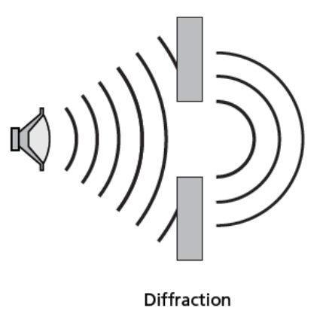

Sound Pressure Graphs
When comparing amplitudes and frequencies, a graph of sound pressure over time is a good method to use. You worked with this type of graph in the sound editing program.
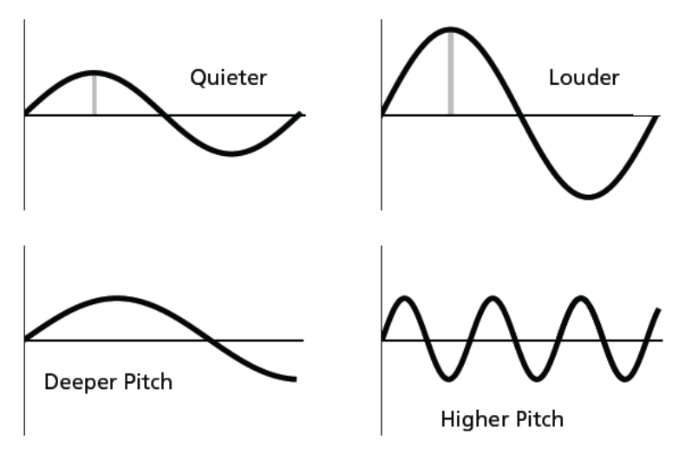

Rays
Representing waves as rays—line segments with arrows to show the direction of travel—is the clearest way to show some wave behaviors, such as reflection.
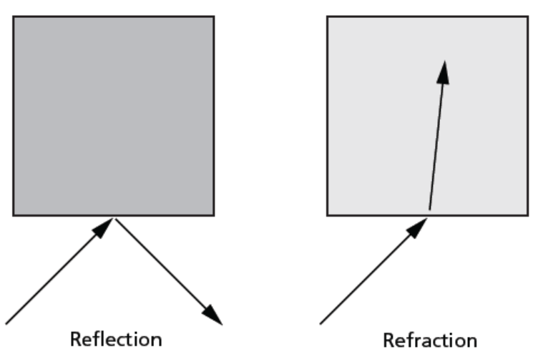

Frequency Spectra
When comparing the timbres of two musical instruments, a graph showing the amplitude of each frequency clearly illustrates the harmonics and overtones.



