Name Date
Handout 1: Unit Overview
The Path to War: Using Visual Media to Understand the Causes of World War II
How do filmmakers bring history to life? How do they use the historical record to shape their own storytelling? In this unit, you will assume the role of a filmmaker creating a film scene from a key event leading up to World War II in Europe. Before choosing the specific event during which your scene takes place, you will need to learn about the circumstances, incidents, and motivations that created the conditions for war in Europe.
As you explore the causes of World War II, you’ll examine images of historic events and read eyewitness accounts and documents created by historians and others. In the process, you’ll learn what it takes to accurately portray stories based on occurrences in the past.
Your work in this unit will revolve around the following questions:
- What were the causes of World War II?
- What materials can help us understand significant events, such as the causes of World War II, that profoundly influenced the course of history?
- How do filmmakers and others who create media set in the past interpret history, and how do these interpretations influence our understanding of the past?
Unit Project
For the unit project, you and your team will create a written storyboard for a scene in a film set between World Wars I and II. With your team, you will create a visual timeline of events leading up to World War II. Each team member will then write a brief summary of the causes of World War II. Finally, as a team, you will choose an event from your timeline to depict in a film scene and create a written storyboard for the scene.
What You Will Do in This Unit
Learn about events in Europe in the years between World War I and World War II. Read about people, places, and occurrences during the interwar years in Europe.
Create a visual timeline. Work with your team to construct a timeline of key events that pushed Europe toward World War II.
Write a summary of the causes of World War II. Use your team’s visual timeline to write a brief summary of the events in Europe that led to World War II.
Conduct research about an event leading up to World War II. With your team, choose and research an event to use as a backdrop for a scene in a historical film.
Create a written storyboard. As a team, develop the story behind your scene and create a written storyboard for the film scene.
Vocabulary Used in This Unit
Allied powers: The military and political alliance of countries led by England, the United States, and the Soviet Union that fought the Axis powers in World War II.
Appeasement: The political strategy of placating a potentially hostile nation by granting concessions in the hope of avoiding war.
Axis powers: The military and political alliance of countries led by Germany, Italy, and, later, Japan that fought the Allied powers in World War II.
Fascism: A movement, ideology, or attitude that favors dictatorial government, centralized control of private enterprise, repression of all opposition, and extreme nationalism.
Inference: A conclusion based on evidence or reasoning.
Nationalism: Excessive or fanatical devotion to a nation and its interests, often associated with a belief that one country is superior to all others.
National Socialism: The ideology of the Nazi Party; sometimes called Nazism.
Nazi: Short version for the German name of the National Socialist German Workers Party, a right-wing, nationalistic, and anti-Semitic political party formed in 1919 and headed by Adolf Hitler from 1921 to 1945.
The Reichstag: The seat of parliamentary government in Germany.
Reparations: Compensation demanded of a defeated nation by the victor in a war.
Storyboard: A “blueprint” depicting sequences of scenes for films, TV shows, video games, animations, and advertisements. Storyboards help filmmakers organize and sequence their work.
Synagogue: The place of worship and communal center of a Jewish congregation.
Name Date
Handout 2: The Path to War Project Description
You will work as part of a team to develop a story for a film scene from one of the key events leading up to World War II. Your team will:
- create a visual timeline of events in Europe between World War I and World War II
- choose an event from your timeline to use in a film scene dramatizing one of the causes of World War II
- develop a story that takes place during the event
- create a written storyboard for a film scene based on your story
- present your storyboard to the class
Storyboards are a series of drawings or sketches that are often used as “blueprints” for films, animations, and advertisements. Storyboards help film directors and others organize and sequence their work. For this project, you will create a written storyboard that describes the characters, setting, and events in your film scene.
Step 1: Create a Visual Timeline
Your teacher will assign readings about the circumstances in Europe between World War I and World War II. You and your team will use the readings, your notes, and class discussions and activities as the basis for your team’s timeline.
With your team, you will create a timeline of important people and events leading up to the beginning of World War II in Europe. On your timeline, you will organize items—such as photographs, illustrations, and quotes—in chronological order, and create an information key for additional details and facts.
Through class discussions and activities, you will add information to your timeline. You will include both primary source information, such as photographs, eyewitness accounts, advertisements, cartoons, quotations, and letters, and secondary source information from accounts given by historians.
Step 2: Choose an Event to Dramatize
With your team, you will choose an event from your timeline and create a story for a film scene that takes place during that event. Your story will powerfully dramatize one of the events that led to World War II.
To choose your event, you will consider four key factors:
- Real-life historical characters
- Visual and written information about the physical setting of the event
- Quotations
- Particularly dramatic episodes or moments
Step 3: Outline the Story
You and your team will describe the characters and setting in the story for your film scene and decide on a point of view from which to tell the story.
You will use historical details to help you visualize your film scene by looking carefully at the details you included on your visual timeline.
Step 4: Create a Written Storyboard
Using your story outline, you and your team will create a written storyboard for the sequence of shots in your film scene. You will describe what the audience actually sees as well as what you, as filmmakers, want the audience to infer during each shot.
Step 5: Present Your Work to the Class
Your team will present your storyboard to the class. To help your classmates visualize your film sequence, you may decide to describe it orally, act it out, or create visuals to go along with the written storyboard.
Your presentation should address these questions:
- Why did your team choose to depict this particular event? What is its historical significance as one of the causes of World War II?
- How does your written storyboard tell a particular story?
- What process did you use to choose the characters and setting for your story?
Be prepared to answer questions on your presentation and on the historical content of your work.

Name Date
Assessment Checklist: The Path to War Project
Use this assessment to help create your visual timeline and written storyboard. Make sure to include all the requirements. Your teacher will use this assessment to evaluate your work.
Requirements | Percentage of Total Grade |  |  | Comments
Visual Timeline |  |  | Student Comments |  | Teacher Comments
Includes key events that occurred in Europe between World War I and World War II. |  | 30%
Lists events accurately and in chronological order. |  | 20%
Provides important details associated with events, such as people, places, documents, and quotes. |  | 20%
Demonstrates knowledge of causative events leading up to World War II in Europe. |  | 30%
Total |  | 100%

Written Storyboard |  | Student Comments | Teacher Comments
Clearly and effectively details a film scene that occurs during an event leading up to World War II. | 40%
Provides a convincing description of setting and characters. | 20%
Includes both visual information about the scene (such as camera angle and the position of characters) and other details, such as character dialogue. | 20%
Accurately describes historical details. | 20%
Total | 100%

Name Date
Self-Assessment Checklist: Teamwork
Use this assessment to help you assess and improve your teamwork skills.
Criteria | Comments
My Individual Teamwork Skills: As a team member, I . . .
Listen to my teammates’ ideas
Ask questions of my teammates, in order to help them clarify their ideas
Actively participate in team discussions
Contribute my own ideas, and/or piggy-back or build on my teammates’ ideas
Help my team evaluate information, and propose creative solutions
Communicate my ideas clearly and defend my ideas and opinions with specific evidence
Respect my teammates and their opinions
Compromise when necessary
Help and offer assistance to other team members
Do my share of the work

Our Team’s Teamwork Skills: As a team, we . . .
Understand our team’s goal
Identify the tasks that we need to accomplish
Assign tasks to different team members
Know each individual’s role and tasks
Communicate clearly, listen, and resolve disagreements without attacking or blaming
Plan tasks and set deadlines
Meet deadlines
Name Date
Handout 3: Creating a Visual Timeline
A timeline is a linear arrangement of events organized in chronological order. It is a great visual aid that can help you understand the connections between events. For this project, creating a timeline is the first step in planning your film scene.
As part of your unit project, you and your teammates will create a visual timeline of the events leading to World War II. You will use images, quotes, and drawings to illustrate these events. Once completed, you will use your team’s visual timeline to choose an event as a backdrop for your final project: a written storyboard for a film scene. You will use your timeline to add important historical details to your storyboard.
Step 1: Draw the timeline on chart paper.
Have a team member label the beginning of each decade: 1920, 1930, and 1940. Label the beginning and end of the timeline with these dates and events:
- 1919: Treaty of Versailles ends World War I
- 1939: European countries make alliances
Label the five-year midpoint in each decade. As you add events to your timeline, mark and label the intervening years as necessary.
Step 2: Add events to the timeline from your readings, notes, and class discussions.
- Put events in chronological order.
- Check any inconsistencies in team members’ notes against the readings.
- Choose common language to use.
- Decide which events to include on the timeline.
- Write a brief description of each event.
Step 3: Add images and quotes.
Bring your timeline to life by adding visual images and quotes from the class activities.
Step 4: Update and revise your timeline.
As you learn more about the events leading to World War II, you’ll likely find more information about a particular event, discover a new image, or come across a quote that provides insight into the time period and/or inspiration for your team’s written storyboard. Decide with your team what additional information to include on your timeline.
Name Date
Handout 5: Notes on Images 1–3

Image 1: Photograph of French premier George Clemenceau in the ruined streets of Noyon, France
- World War I created devastation across Europe:
  - 59 million troops had been mobilized.
  - More than 8 million people died.
  - More than 29 million people were injured.
  - France suffered severe losses: The number killed equaled 10.5 percent of the able-bodied male population.
  - England’s losses were also severe: 5.1 percent of the able-bodied male population.
- The destruction and casualties led to anti-war sentiment and a pervasive longing for peace during the 1920s and 1930s.
- Anti-war sentiment is seen in a number of treaties made during the interwar years, such as the Kellogg-Briand Pact of 1928, which attempted to eliminate war as an instrument of national policy.
Image 2: English cartoon: Peace and Future Cannon Fodder
- The peace conference talks that ended World War I resulted in the signing of the Treaty of Versailles in 1919.

- The conditions and stipulations in the Treaty of Versailles were determined by France, England, and the United States, as represented by:
  - French Prime Minister Georges Clemenceau
  - British Prime Minister David Lloyd George
  - U.S. President Woodrow Wilson

- The conditions imposed on Germany by the Treaty of Versailles were more drastic and punitive than the people of Germany had expected.
Image 3: Maps of pre-1919 Europe and post-1919 Europe
- The Treaty of Versailles, signed in 1919 at the end of the World War I, was overwhelmingly unpopular with Germans. Four aspects of the treaty were particularly resented:
  - Loss of territory. Germany lost one-tenth of its land and 6 million subjects.
  - Limits to military force. Germany’s army was reduced to 100,000 troops, and its Air Force and Navy were disbanded.
  - Reparations. The total sum of war reparations demanded from Germany came to 226 billion Reich marks in gold (about $16.2 billion). In 1921, this amount was reduced to 132 billion Reich marks (about $7.1 billion), an amount that Germany was still unable to pay.
  - Clause 231. The language in this clause stated that Germany alone was to blame for World War I.
- The Treaty of Versailles fueled distrust and anger among many Germans toward the new German democratic government that had been forced to sign the treaty. According to some historians, the Nazi party used this resentment to gain the support of the German people.
Image 1: Photograph of French premier George Clemenceau in the ruined streets of Noyon, France, 1919.

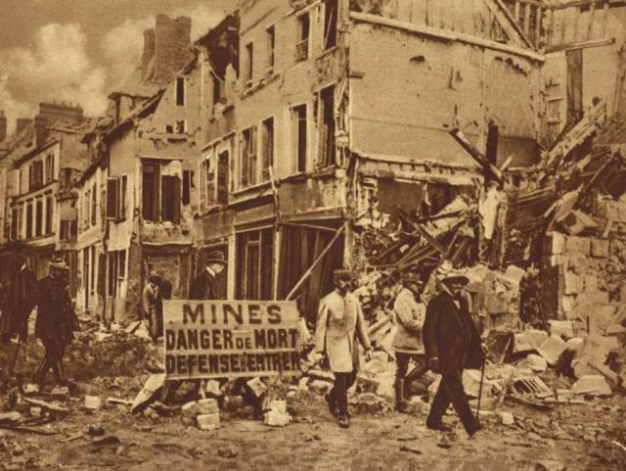

Image courtesy of The New York Times Co.

Image 2: English cartoon: Peace and Future Cannon Fodder

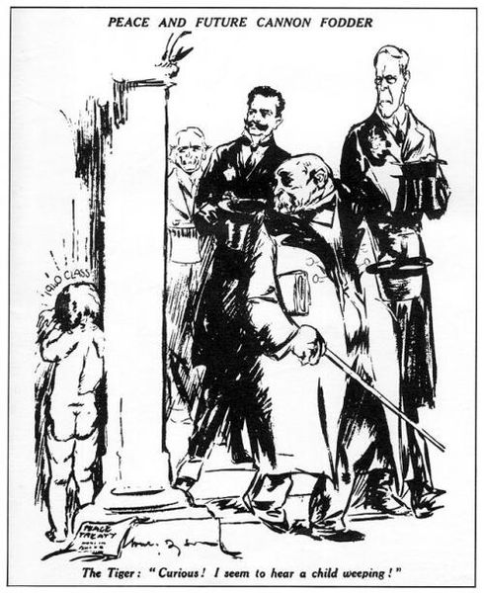

Image printed in the Daily Herald, May 1919, courtesy of Wikimedia commons.

Image 3: Maps of pre-1919 Europe and post-1919 Europe

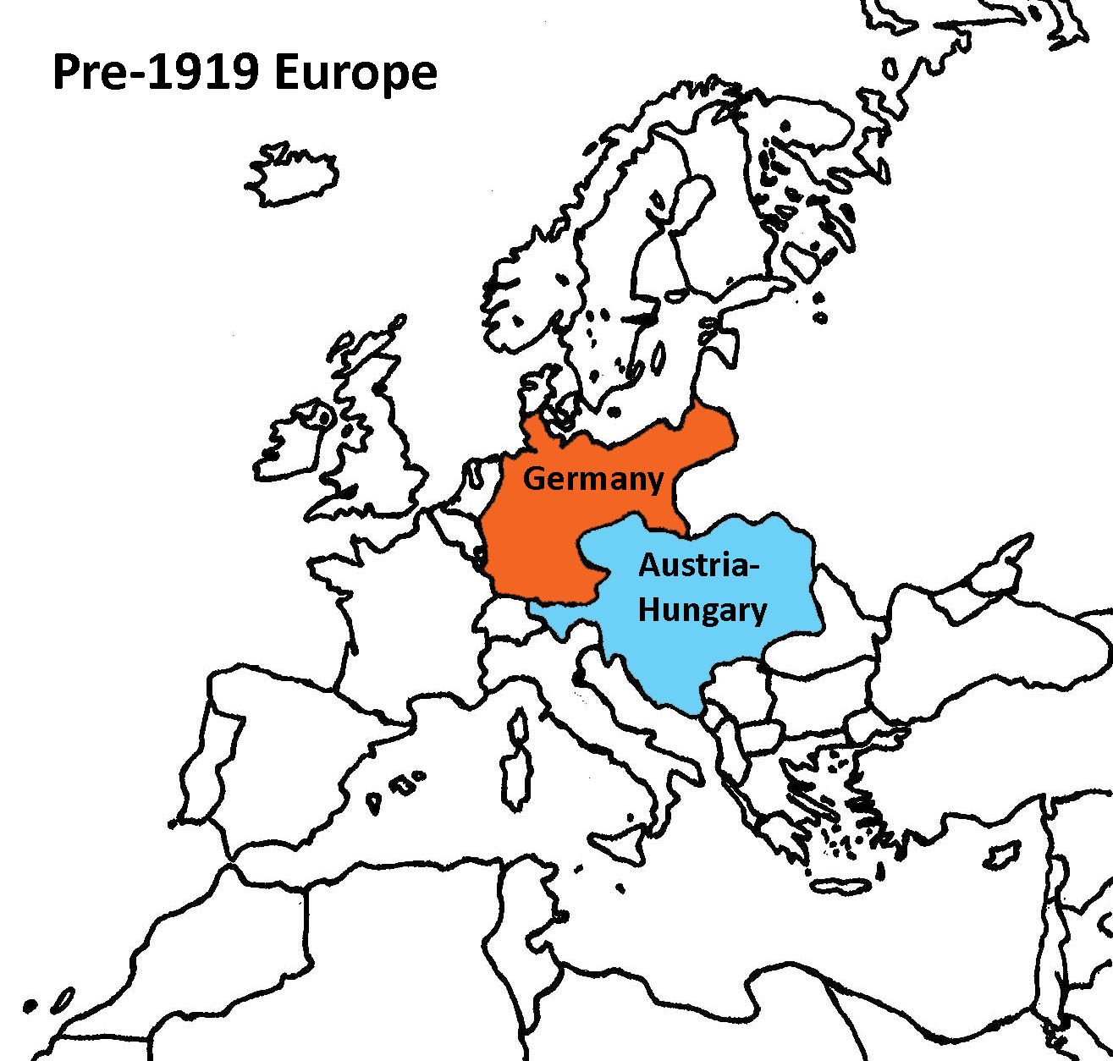

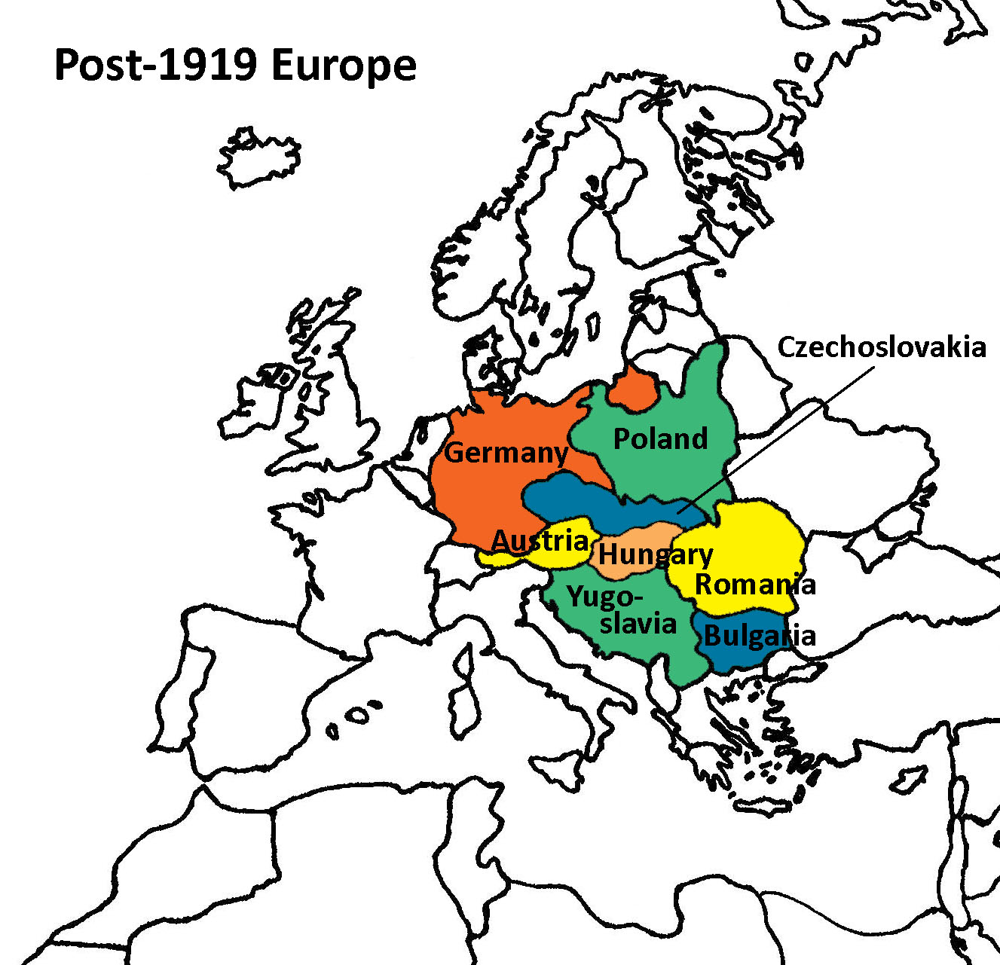

Map by Katie Loesel

Name Date
Handout 6: The Great Depression in Europe

Introduction
The onset of the Great Depression in 1929 stood at the halfway point between two catastrophic wars that defined European history in the first half of the twentieth century: the end of World War I in 1918, and the start of World War II in 1939. Throughout Europe, as in the United States, the Great Depression of the 1930s tested institutions, values, and leadership.

Against the backdrop of both world wars, however, the Depression can seem relatively insignificant. Yet precisely because it emerged at a crucial moment in the interwar period, the Depression merits our attention if we are to understand the course of both European and world history during the twentieth century. To what extent did the economic crisis lead to a questioning in Europe of the effectiveness and sustainability of democratic institutions, and how did people’s concerns, doubts, and fears translate into political action?
Context: October 29, 1929
The stock market crash of October 1929 led directly to the Great Depression in Europe. When stocks plummeted on the New York Stock Exchange, the world noticed immediately. After the crash, it soon became clear that the world’s economies were more interconnected then ever. The effects of the disruption to the global system of financing, trade, and production and the meltdown of the American economy were soon felt throughout Europe.
Causes of the Depression
While historians still debate the precise causes of the Depression, most now agree that the economic crisis began in the United States and then moved to Europe and the rest of the world.
Class Relations Before the Depression
While European economies during the 1920s experienced unemployment and the subsequent poverty, hunger, and despair, much remained invisible to the general public. To the middle and upper classes, the lives of the poor were either invisible or frightening. The Depression would transform many societies by making visible the unemployment, distress, and despair already there.
Germany’s Postwar Debt
With the onset of the Depression, both the hopes of peaceful class reconciliation and the willful ignorance of working-class desperation came to an end. Poverty was evident everywhere, and conflict, rather than compromise, between classes appeared unavoidable. In Germany, the Depression struck an already weakened economy barely beginning to recover from the combined effects of wartime destruction and postwar reparations. The democratic Weimar government was deeply in debt, yet it tried to maintain high levels of unemployment benefits to prevent growing dissatisfaction among the lower classes.

Flow of money between U.S. banks and the German, England, and French governments before 1928
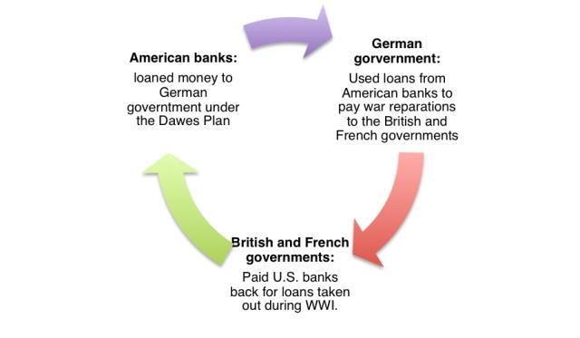

The German economy was linked to the economies of European countries through the Dawes plan, an attempt following World War I for Britain, France, and Russia to collect war reparations debt from Germany. Under the terms of the Dawes plan, American banks loaned money to the German government, which used the loans to pay reparations to the French and British governments, which in turn used the money to pay war debts to American banks. The high interest rates sustained by the Dawes plan made Germany an attractive debtor for American banks, and, for several years, considerable money flowed from the American financial sector into Germany. But by 1928, American banks had ceased to make loans under the Dawes plan. Germany, however, still had to repay its American loans in addition to making reparations payments.
The Collapse of German Banks
The German government’s initial response to the crash of ‘29, and the subsequent withdrawal of American capital, involved cutting public services. The traumatic experience of extreme inflation in the early 1920s caused the government to respond to the crisis by decreasing, rather than increasing, public expenditure, which in turn worsened the economic conditions.

Declining productivity, mass unemployment, and business failures ensued. Chancellor Bruning resorted to the use of emergency powers granted by the President to implement measures so unpopular they earned him the name “Hunger Chancellor.” The collapse of German banks in 1931 marked the start of a downward spiral into depression. In 1932, Germany defaulted on its reparations; two years later, Britain and France defaulted on their own war debts, which were owed primarily to the United States.

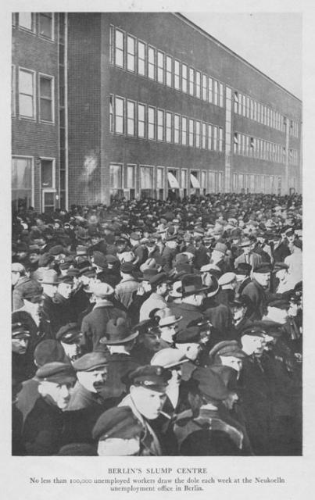
No fewer than 100,000 unemployed workers drew the dole each week at the Neukölln unemployment office in Berlin. Source: H. Tiltman, Slump! A Study of Stricken Europe Today (1932: Jarrolds Publisher London Limited).

Election Campaigns and Political Consolidation
In addition to direct action on the streets by, in most cases, more extreme political movements, elections became an important measure of the impact of the Depression on Europe. Parties on the extreme left, such as the Communist Party, claimed that the interests of the working class could be served only by revolutionary, and inevitably violent, overthrow of the existing social, political, and economic order. Socialist parties, such as the Labour Party in Britain and the Social Democrats in Germany, argued that working-class interests were better served by working through the political system for policies that would promote equality, democracy, and peace. To the right of the Socialists stood a variety of parties, such as the Conservatives in Britain and the Catholic Center Party in Germany, which argued that middle- and upper-class interests were best served by traditional policies that protected property, maintained order, and promoted changes through the existing economic system.

In addition, a new force of political radicalism emerged on the extreme right arguing for stronger governments that took direct action to promote national interests for all classes at the expense of foreign and minority interests. The Nazi Party in Germany was the strongest example of such politics, although similar movements emerged in Britain and France as well.
The British Response to the Depression
In Britain, Prime Minister Ramsay Macdonald’s Labour government responded to the economic crisis caused by the Wall Street crash and capital flight to America by imposing further restrictions on government spending, including threats to cut already meager unemployment payments. In the elections of 1931, the National Government, a new party, won a solid victory in the 1931 elections. The National Government seemed to represent a middle ground that strengthened moderate forces of both the left Labour Party and the right Conservatives. The election thus appeared as a sign of reassurance in a time of increasing demonstrations and protests in the streets. Such a position of strength allowed the National Government to implement several unpopular economic policies. But the government never undertook a major recovery effort, like the New Deal in the United States, and unemployment remained high through the end of the decade.
The Rise of the Nazi Party in Germany
In Germany, the fall 1930 elections returned only a handful of new seats for the parties supporting the Chancellor, while the extremist parties gained the most seats: twenty-three additional representatives for the Communists on the left and ninety-five new seats for the Nazis on the right, making the latter the second-largest party in the German Reichstag, or Parliament. In the election, more than six million Germans voted for the Nazi party. In subsequent elections, Nazi support continued to grow at the expense of moderate parties, such as the Social Democrats and the Catholic Center Party. By 1932, the Nazi Party had won more than one-third of the seats in the Reichstag and had become the largest single party within the representative body, with 196 seats compared to 121 seats held by Social Democrats. The growing strength of the Nazi party from 1930 to 1932 illustrates how the effects of the Depression shaped the increasing radicalization of German politics in ways that undermined the existing democratic government.
The Popular Front in France
In France, the Popular Front emerged as a powerful symbol of the collective determination to overcome both economic crisis and social division. Representatives of the Socialist, Liberal, and Communist Parties formed the Popular Front in early 1936. The program of the Popular Front thus illustrated combined efforts to mediate political divisions while promoting a program in support of government intervention in the economy, the defense of civil liberties, and the protection of social welfare.
Conclusion
The real end of the Depression in Europe came only, as in the United States, with the onset of war in 1939. The increasing military expenditures during the late 1930s put millions to work in ways that had not been possible through the more limited recovery programs adopted by the governments of Britain, France, and Germany in the earlier years of the Depression. Yet certain steps taken during the 1930s illustrate how the responses to the Depression shaped the political situation on the eve of war. In England, “hunger marches” emerged as an effective means of social protest and political mobilization. In contrast to the situation prior to the Depression, the British public was far more aware of the suffering of those in situations of economic distress.

German recovery from the Depression under the Nazi government occurred, in the words of Gordon Craig, “with a speed that amazed the world.” Hitler’s popularity derived largely from his explicit promise to put Germans back to work. Rearmament played the greatest role in economic growth, although government investment in industry, public works programs, and tax relief for major industries also contributed to the rapid recovery. Unemployment, which had reached six million in 1932, fell to less than one million by 1936.

Claims that Hitler ended the Depression certainly overstate the extent of his personal role in the transformation. Moreover, within Germany, the renewed growth of the economy and the profound changes in public attitudes accounted for increased support for Hitler’s government, which had begun to shift its attention toward foreign policy.

Rearmament also played a role in French recovery from the Depression, although the bitter political disputes over the perceived threat from Germany, in combination with collective memory of the costs of the First World War, made the French government reluctant to invest heavily in militarization. While the Popular Front government led a modest recovery from the Depression, continuing political divisions contributed to the anxiety and ambivalence that characterized the French response to the increasingly aggressive stance taken by Hitler. The tensions within the French democratic government thus constituted yet another consequence of the Depression, and one that contributed indirectly to the coming of war in 1939
Name Date
Handout 7: Ideas in Images
The quotes below were made by people or printed in a newspaper during the years between the end of World War I and the start of World War II.
Match each quote with at least one image displayed by your teacher. Write the number of the image or images next to the quote that best illustrates the image’s meaning, and in the space provided write why you paired each quote with a certain image.
Image Number(s) | Quote | Why did you choose to pair the image and the quote/
A. My father was a lawyer, and he had taken out an insurance policy in 1903, and every month he had made the payments faithfully. It was a 20-year policy, and when it came due, he cashed it in and bought a single loaf of bread.
—Walter Levy, internationally known German-born oil consultant in New York (n.d., as quoted in Commanding Heights: The German Hyperinflation, 1923 on PBS)
B. Does the experience of the Great War and of the years that followed it give us reasonable hope that if some new war started that would end war any more than the last one did? No. I do not believe that war is inevitable . . .
It seems to me that the strongest argument against the inevitability of war is to be found in something that everyone has recognized in every part of the House. That is the universal aversion from war of the people, their hatred of the notion of starting to kill one another again . . .
—Neville Chamberlain, Prime Minister of the United Kingdom, 1938
C. The definitive solution lies in an extension of our living space, that is, an extension of the raw materials and food basis of our nation.
—Adolf Hitler, German Chancellor, 1936 (from Bell, 1986, p. 46)
D. What I saw was hordes of people standing in front of a beautiful synagogue, and throwing stones through these magnificent, uh, colored windows. And, uh, as we arrived, of course we ran past the, the, the place itself, the noise, the shouting, the screaming. I suppose there was an, an aura of, of eeriness about it, because we still didn’t know what was happening, but I suppose just the mere fact that so many people were there and were screaming and shouting and, and throwing stones into the, uh, stained glass windows was enough to make us run…. [It] then unfolded slowly but surely the, uh, grim story of what happened during the night, that the synagogues all through Germany had been set on fire, destroyed.
—Johanna Gerechter Neumann, describing Kristallnacht in Hamburg, Germany (from a 1990 interview housed in the US Holocaust Memorial Museum)

E. We have been reduced from a position where the very word “war” was considered one which would be used only by persons qualifying for a lunatic asylum. We have been reduced from a position of safety and power—power to do good, power to be generous to a beaten foe, power to make terms with Germany, power to give her proper redress for her grievances, power to stop her arming if we chose, power to take any step in strength or mercy or justice which we thought right—reduced in five years from a position safe and unchallenged to where we stand now . . .
We are in the presence of a disaster of the first magnitude which has befallen Great Britain and France. Do not let us blind ourselves to that. It must now be accepted that all the countries of Central and Eastern Europe will make the best terms they can with the triumphant Nazi power.
—Winston Churchill, British Cabinet Minister, 1938
F. Everywhere in Europe—in Italy, in Sweden and Norway, in Rumania and Bulgaria—the number of unemployed grows rapidly. The only exception is France. Because of the favorable economic situation and the low birth-rate there is practically no unemployment in France. Tens of thousands of foreign workers have come to France in the last few years for work. With the least change in the economic conditions they will be thrown out of work and many more also—and unemployment will hit France too. This is how things stand in Europe.
—From “20,000,000 Unemployed in World,” Revolutionary Age (7 April 1930), 2

Image 4: Photo: German hyperinflation
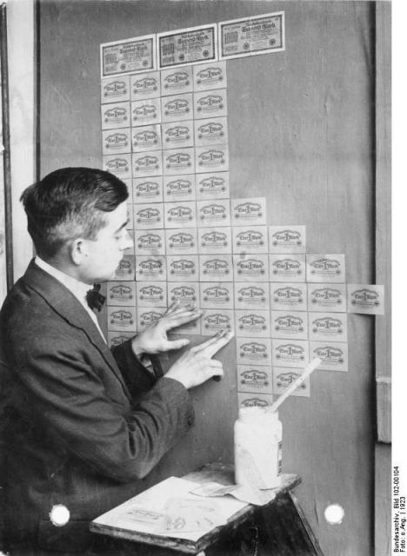

Image courtesy of Deutsches Bundesarchiv (German Federal Archive).

Image 5: Chart: Unemployment statistics for Europe, 1929–1933

Country | 1929 | 1930 | 1931 | 1932 | 1933
Austria | 225,000 | 239,000 | 304,000 | 417,000 | 456,000
Belgium | 28,000 | 42,000 | 207,000 | 350,000 | 383,000
Czech | 50,000 | 88,000 | 340,000 | 634,000 | 878,000
France | 9,000 | 14,000 | 72,000 | 347,000 | 356,000
Germany | 2,484,000 | 3,041,000 | 4,744,000 | 6,034,000 | 5,599,000
Norway | 24,000 | 23,000 | 29,000 | 38,000 | 42,000
Poland | 177,000 | 289,000 | 373,000 | 360,000 | 280,000
Sweden | 44,000 | 42,000 | 73,000 | 99,000 | 121,000
U.K. | 1,204,000 | 1,694,000 | 2,666,000 | 2,660,000 | 2,821,000
Yugoslavia | 12,000 | 10,000 | 12,000 | 23,000 | 23,000
Source: Lionel Robbins, The Great Depression (New York: Macmillan, 1936), 213.
Image 6: Photo: The 1936 remilitarization of the Rhineland

Image 7: Leaders of England, France, Germany, and Italy prepare to sign the Munich Agreement, 1938
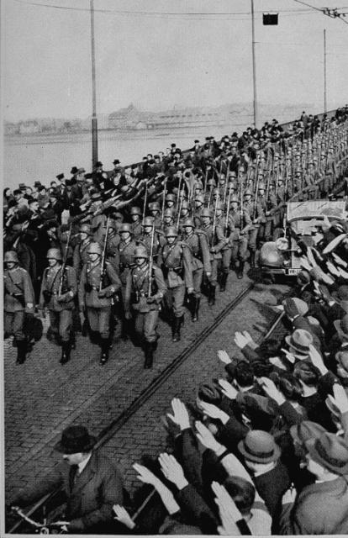

Photograph from United States Holocaust Memorial Museum.

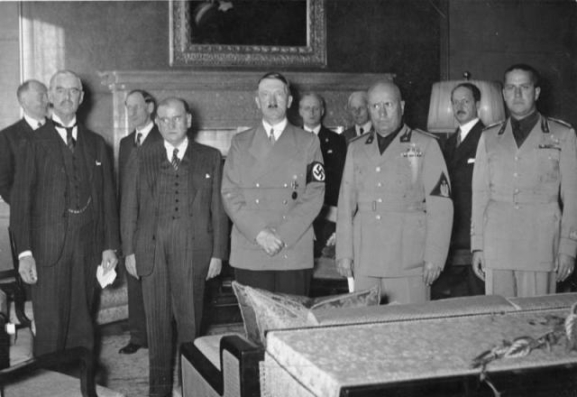

Image courtesy of Deutsches Bundesarchiv (German Federal Archive).

Image 8: Image 8: Photo: The Boerneplatz synagogue in fl ames during Kristallnacht (“The Night of Broken Glass”), Frankfurt am Main, Germany, November 10, 1938
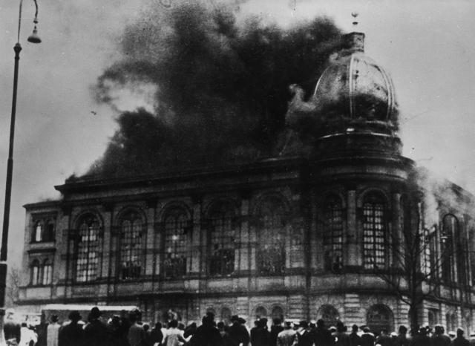

Photo from BPK via Art Resource

Name Date
Handout 8: Notes on Images 4–9
Image 4: Photo: German hyperinflation
- In the years after World War I, Germany suffered unprecedented economic turbulence. Prices rose dizzyingly, while German currency—the mark—lost its value. By November 1923, one U.S. dollar equaled 1 trillion marks.
- After the experience of hyperinflation, the fledgling Nazi party, whose attempted coup had failed in 1923, legally won 32 seats in the next election.
Image 5: Chart: Unemployment statistics for Europe, 1929–1933
- The stock market crash on Wall Street in October 1929 led to the Great Depression in Europe.
- The Great Depression tested the major financial, social, and political institutions in Europe. The unemployed in Germany, Britain, and France took to the streets, staging protests and strikes to call attention to their situation.
- The economic crisis gave rise to extreme political movements, such as the Nazi Party in Germany. Similar far-right movements also emerged in Britain and France in response to the economic downturn. In the autumn of 1930, the Nazis gained 95 new seats in the German parliament.
- Germany recovered from the Great Depression under Nazi rule. Unemployment fell from about 6 million in 1932 to less than 1 million by 1936. The recovery was largely due to Hitler’s policy of rearmament but also to government investment in industry, public works, and tax relief for major industries. This economic miracle increased support for Hitler in Germany and around the world.
Image 6: Photo: The 1936 Remilitarization of the Rhineland
- The Rhineland is the general name for the land on both sides of the river Rhine in the west of Germany. The remilitarization of the Rhineland was an open violation of the Versailles Treaty of 1919.
- Many local Germans who lived in the Rhineland supported the remilitarization because of their resentment over the French occupation of the area until 1930.
- Even though the remilitarization violated the Treaty of Versailles, France and England decided not to use force to stop the German military’s action. At the time, France was in a financial crisis and holding political elections; no incoming French president wanted to be responsible for waging an unpopular war against Germany. Most English politicians agreed with France’s decision not to act.
Image 7: Leaders of England, France, Germany, and Italy prepare to sign the Munich Agreement, 1938, and Image 8: Photo: German troops marching into the Sudetenland, Czechoslovakia, October 2 or 3, 1938
- In 1938, Chamberlain flew to Germany to meet with Hitler twice before the Munich Conference on September 29. At the conference, Germany, Italy, England, and France agreed to cede the Sudetenland, an area of Czechoslovakia with a majority German population, to Germany.
- When Chamberlain returned to England, he was received by many with enthusiasm. He gave a now infamous speech announcing to the world that the talks in Munich had been successful and meant “peace for our time.” With the outbreak of war barely one year later, Chamberlain’s belief was proved false.
- Many citizens of Czechoslovakia were angered by the Munich Agreement, especially as no member of the Czechoslovakian government was allowed to participate in the conference.
Image 9: The Boerneplatz synagogue in flames during Kristallnacht, Frankfurt am Main, Germany, November 10, 1938
- Kristallnacht—literally, “Night of Crystal”—refers to the wave of violent anti-Jewish actions that took place on November 9 and 10, 1938, throughout Germany and Austria. The name came from the large quantities of glass fragments from the broken windows of shops, homes, and synagogues that littered the streets the following day.
- Nazi party members and Hitler Youth units destroyed 267 synagogues and shattered an estimated 7,500 Jewish-owned stores and businesses. Kristallnacht claimed the lives of at least 91 Jews.
- Kristallnacht is seen as a turning point in Nazi Germany’s persecution of Jews. The passive response of most Germans signaled to the Nazi party that the public would tolerate more radical measures to eliminate Jews from German political and economic life.

Name Date
Handout 9: Describe Your Scene
Use this worksheet to plan a five-minute film scene. (Your team will use these notes later to create your written storyboard.) Include historical details from your visual timeline so that you can create a compelling and believable scene.
Visualize the Setting
Where and when does the scene take place—in a rural area, in a city, or somewhere else? At night, or during the day? What season of the year is it? Describe the landscape and architectural features, as well as other objects and artifacts in the surrounding area.

Visualize the Way of Life
How are people living at this time? What kind of clothing and shoes do they wear? What modes of transportation do they use?

Visualize the Characters
Who are the characters in your scene? What do they look like? How old are they? Describe each character’s role in relation to your chosen event.

Determine Point of View
From which character’s viewpoint will you tell the story—that of an ordinary citizen who might have lived during this period, such as a teacher or a soldier, or that of an actual historical figure, such as a politician or a military leader?

Plan Your Scene
Your short scene needs the basic story components—a beginning, middle and end.
Beginning:

Middle:

End:

Justify Your Choice
During what World War II-related event is your scene set? Why did you choose to depict a scene during this particular event? Why is your scene historically important?

What visual elements from your timeline could you choose to tell the story in your scene? Why might you choose those elements?

Name Date
Handout 10: One Girl’s Story
This story is told by Margrit Fischer, a kindergarten teacher born in 1918. In 1942, a Third Reich organization promoted her to a key teacher training position. Though pressured to join the Nazi Party, she never did.
I was born in the last year of the First World War, and from earliest infancy I was aware of Germany’s hatred for the Treaty of Versailles. I remember very clearly my mother’s grief over her fallen brothers and cousins, and my family’s very strong antiwar feelings. The inflation that occurred after the war, which I remember even though I was only five, strengthened those feelings. Then we had a few calmer years, but the early 1930s was a catastrophic time for Germany.
In Bremen, where I grew up, there were lines in front of the employment offices, lines in front of the food distribution centers, longer and longer lines every day. There were parades and demonstrations by the Communists and Social Democrats with their beating drums. And these demonstrations were not always peaceful: every night there was fighting, and we lived right next to the working-class district, so we often heard gunfire. There was a great sense of uneasiness everywhere. So when this odd Hitler came along with his slogans that captured the essence of what was in the hearts of the German nationalists, then it became clear, even to a child that things would change very soon.
The mood of the country was explosive, and Hitler’s slogans, which came more and more into the public sphere after 1931, resonated well among the people. At that time he never spoke of war. He promised us that unemployment would end, and that Germany would once again take its place in the world as a state worthy of respect. And I think that was probably the key thing, for the Treaty of Versailles had cut to the root of Germany’s self-respect, and a people cannot survive for long without self-respect. So this man was not only admired, but welcomed, longed for.
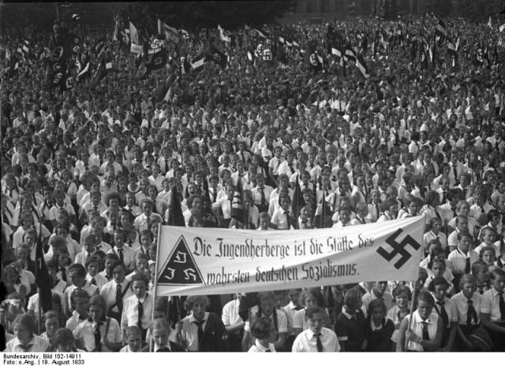

Parade of Hitler Youth in Berlin, 1933. Image courtesy of Deutsches Bundesarchiv (German Federal Archive).
When the change of power happened, and the streets were suddenly peaceful and clean, and there was no more fighting—then all of us, who hadn’t really been for Hitler necessarily, were initially greatly relieved . . .
The jubilation came one or two years later, after unemployment had really been fought and the streets were clean. At that time there was still no mention of war, and no mention of persecuting Jews either, at least not publicly. The most important thing now was that the people really had a feeling of participation. It all happened so quickly in those first four years: first the creation of jobs, then the creation of all sorts of organizations. The previous private associations—the Scouts, the religious groups, and so on—were gradually subsumed into the Hitler Youth. Not everyone had to join. I, for example, did not join the Hitler Youth at first, because I was raised to be very individualistic, and I was wary of big gatherings. But in high school, I had a wonderful teacher who completely embodied the ideals of National Socialism, and she was a role model for me.

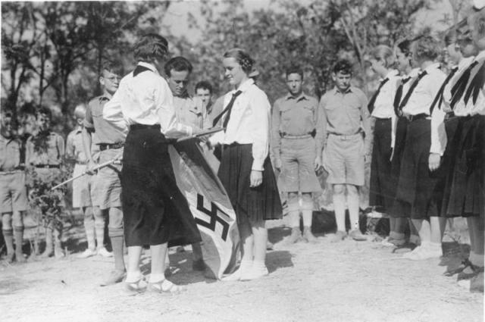

Hitler Youth and League of German Girls, 1935. Image courtesy of Deutsches Bundesarchiv (German Federal Archive).
It is very difficult to capture charisma in words. I was hiking, and I met up with a group of BdM girls [Bund deutscher Mädel, or League of German Girls] on the way up to where Hitler had his residence. I was wearing a dirndl [the traditional German folk dress]. And merely waiting in this group created a feeling of suspense, which then relaxed when the door opened and the Führer walked up to us very matter-of-factly and shook our hands and talked with us—not really like a father, but more like a comrade. He had a very deep understanding of young people, and had an ability to speak with youths. He joked around with us, and asked us where we were from and why we had come; it was a very natural half hour. But his entire personality, his bearing, touched a place in the heart that is quite seldom reached . . . Afterwards, when we hiked down the mountain, we felt like we were walking on air. We fell into each other’s arms and exclaimed how we had been blessed to experience such a half hour—that it was an experience we would never forget for as long as we lived . . .
During the Olympic Games in Berlin, we had a friend from England visit us in Bremen. He thought Germany was incredible, and he said to us, “This National Socialism has made Germany into an entirely different country, and I only wish England could experience something like this.” So by this time, the Germans could again look out on the world with heads held high, and we could again see ourselves as equals amidst the chorus of other countries. We received so much praise from the rest of the world—never was there so much praise for Hitler’s Reich as in 1936.
Name Date
Handout 11: Storyboard Template
Title: ______________________________________ Page: ___ of ___
Created by: _______________________________________________________
# | What’s happening in this shot of the scene?  (Describe what you want the audience to infer about the shot) | What does the shot look like?  (Describe or draw what the audience observes in the shot—characters, setting, action) | Additional information:
Team notes:

# | What’s happening in this shot of the scene?  (Describe what you want the audience to infer about the shot) | What does the shot look like?  (Describe or draw what the audience observes in the shot—characters, setting, action) | Additional information:
Team notes:

# | What’s happening in this shot of the scene?  (Describe what you want the audience to infer about the shot) | What does the shot look like?  (Describe or draw what the audience observes in the shot—characters, setting, action) | Additional information:
Team notes:

This text is used with permission from the Virginia Polytechnic Institute Digital History Project. Adapted from Module 04: The End of Optimism? The Great Depression in Europe, European History: 19th and 20th Centuries, http://www.dhr.history.vt.edu/modules/eu/mod04_depression/index.html.
From The Century (1998) by Peter Jennings and Todd Brewster. New York: Doubleday, p. 171.

